Nama : Nandhita Diva Azzahra

Kelas : XI RPL 5

No Absen : 29

JOBSHEET 4

1. POLIMORPHISM
2. Overloading Method

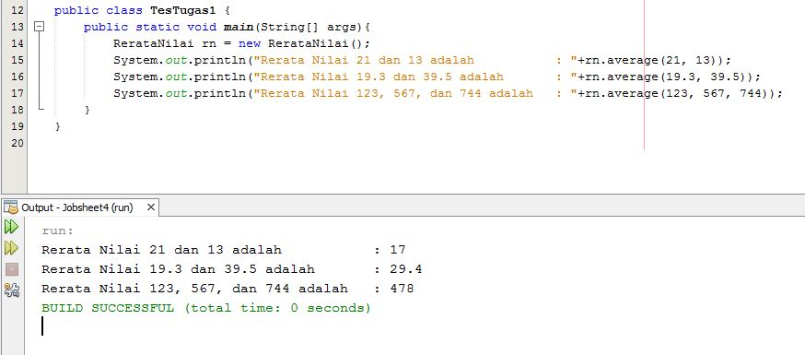

1. Overriding Method

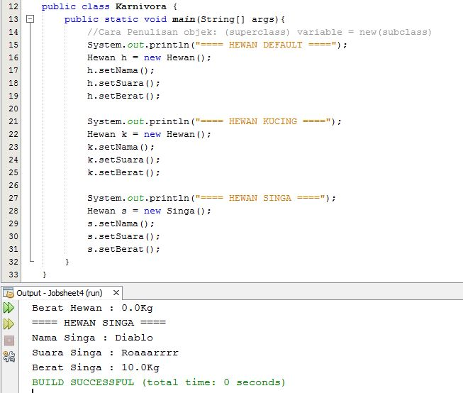

1. ABSTRACT CLASS
2. Hasil Latihan Praktikum

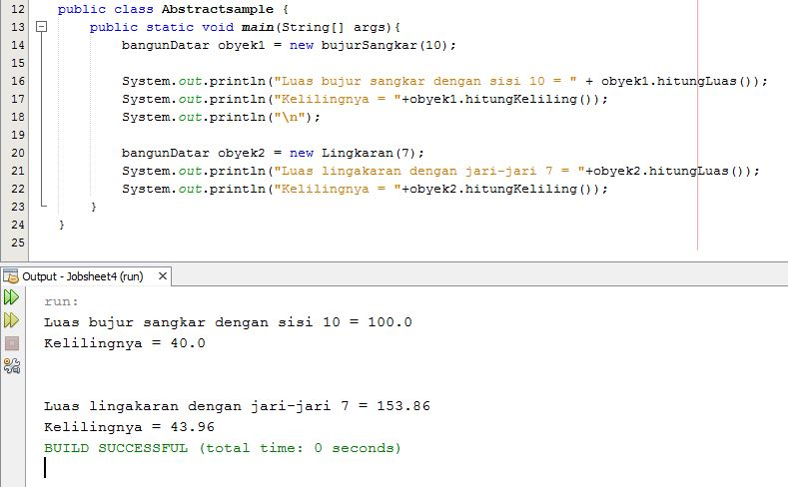

1. INTERFACE

Hasil Praktikum Interface

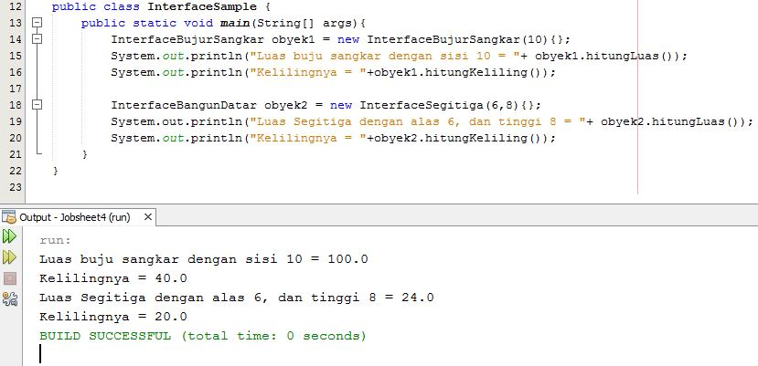

1. TUGAS PRAKTIKUM

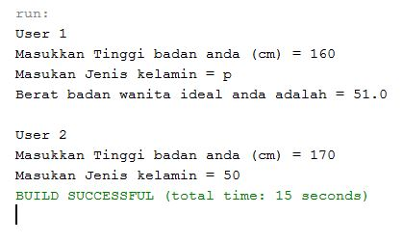

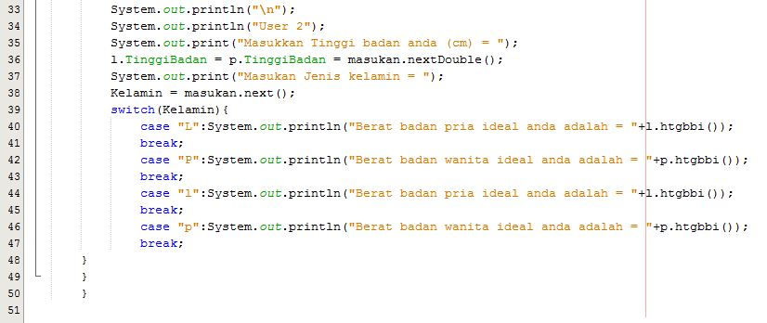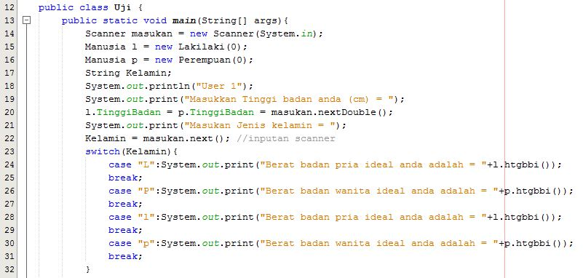

Frame ideal Tubuh

